Q1 (25%) ,Q2 (50%), Q3 (75%),99%, Q4 (100%)

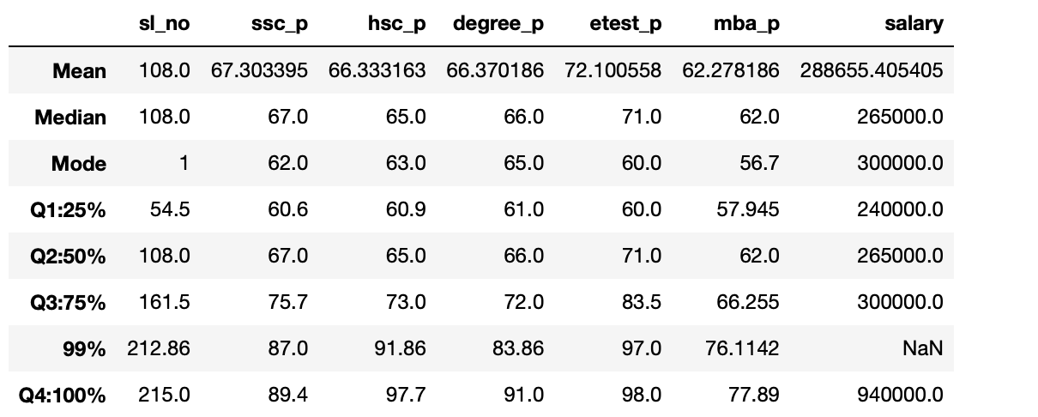

Q1 (25%)

The 25th percentile (Q1) is a value that separates the lowest 25% of the data from the rest. For example, in the "ssc_p" column, the 25th percentile is 60.6, which means that 25% of the secondary education percentages are less than or equal to 60.6.

Q2 (50%) - Median

The 50th percentile (Q2) is the median, which is the middle value when the data is sorted. In the "mba_p" column, the median is 62.0, indicating that 50% of the MBA percentages are below 62.0.

Q3 (75%)

The 75th percentile (Q3) separates the lowest 75% of the data from the remaining 25%. For instance, in the "hsc_p" column, the 75th percentile is 75.7, showing that 75% of the higher secondary education percentages are less than or equal to 75.7.

99%

This represents the value below which 99% of the data falls. In the "etest_p" column, the 99th percentile is 97.0, meaning that only 1% of the electronic test percentages are higher than 97.0.

Q4 (100%)

The 100th percentile (Q4) represents the maximum value in the dataset. In the "salary" column, the 100th percentile is 940,000, indicating the highest recorded salary in the dataset.